**AI-Powered Document Forensics & Verification System**

A comprehensive platform that combines traditional digital forensics techniques with modern machine learning approaches to detect document tampering, verify authenticity, and extract forensic evidence.



In legal proceedings, document authenticity is critical. But detecting sophisticated tampering requires expert analysis that can take days or weeks.Our AI-powered system combines traditional forensics with machine learning to detect tampering in minutes, not days, providing forensic-grade evidence for legal proceedings.

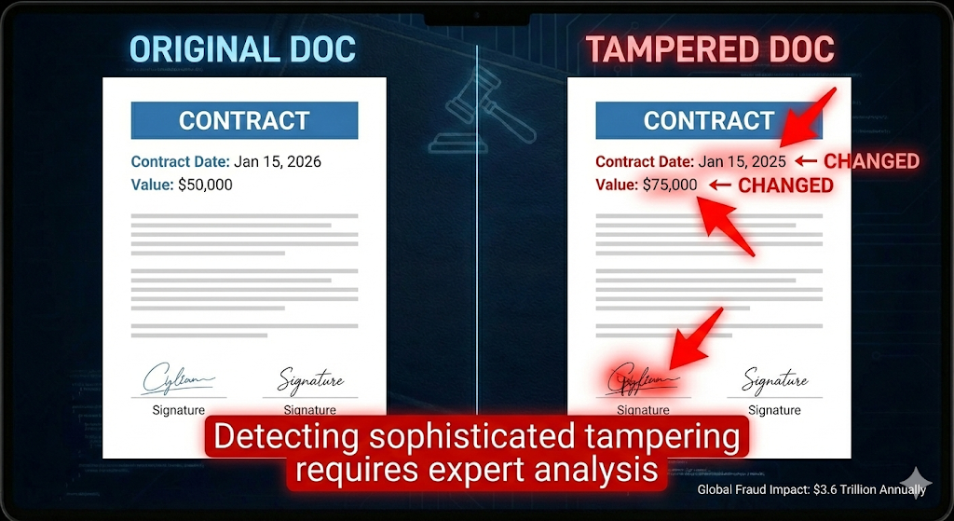

Built on a production-ready microservices architecture with FastAPI, PostgreSQL, and Redis, our system processes multiple document formats using advanced AI models.

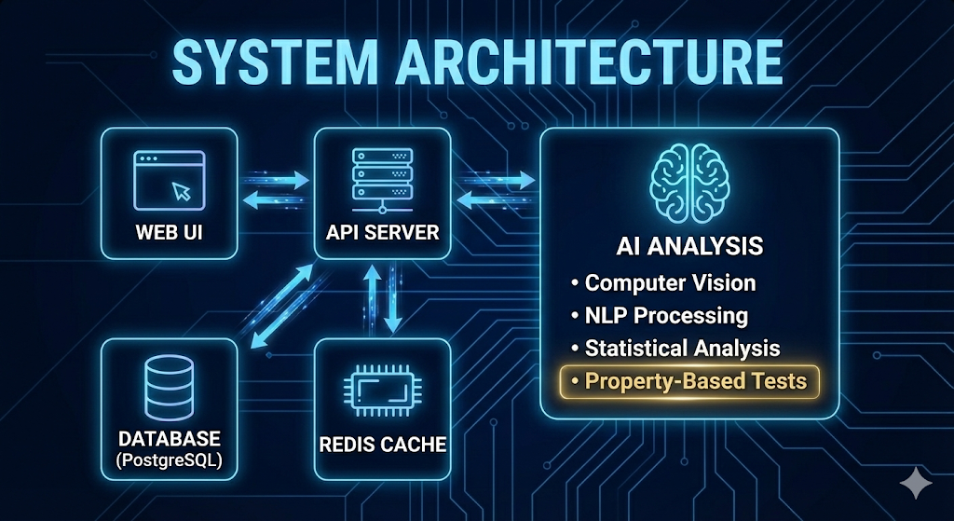

"What makes this unique is our use of property-based testing for forensic validation - ensuring mathematical correctness across millions of test cases. This innovation guarantees reliability for legal proceedings.

**## Features**

- Document Upload & Processing : Support for multiple file formats (PDF, images, Office documents)

- Metadata Extraction : Comprehensive extraction of EXIF data, creation timestamps, and software signatures

- AI-Powered Tampering Detection : Machine learning models for detecting pixel-level inconsistencies and text modifications

- 🆕 Advanced Forgery Detection : Format-specific forgery detection for Word, Excel, Text, Images, and PDF documents

- Word : Revision history, hidden text, style inconsistencies, track changes analysis

- Excel : Formula tampering, hidden content, macro detection, data validation bypass

- Text : Encoding manipulation, invisible characters, homoglyph attacks

- Images : Clone detection, noise analysis, compression artifacts, lighting inconsistencies

- PDF : Digital signature verification, incremental updates, object manipulation

- Authenticity Verification : Multi-factor authenticity assessment with confidence scoring

- Comprehensive Reporting : Detailed forensic reports with visual evidence and expert testimony formatting

- Batch Processing : Efficient processing of multiple documents with progress tracking

- Security & Audit : Cryptographic hashing, encryption, and immutable audit trails

- API Integration : RESTful APIs for system integration and automation

## Architecture

The system follows a microservices architecture with the following components:

- API Service : FastAPI-based REST API

- Worker Service : Celery workers for background processing

- Database : PostgreSQL for data persistence

- Cache/Queue : Redis for caching and message queuing

- Web Interface : Streamlit-based user interface

Let's see the system in action. I'm uploading a legal contract that appears authentic but has been subtly modified.

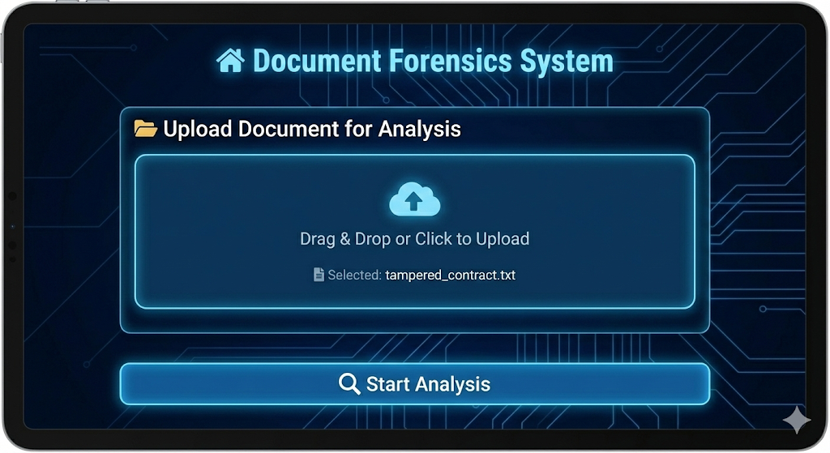

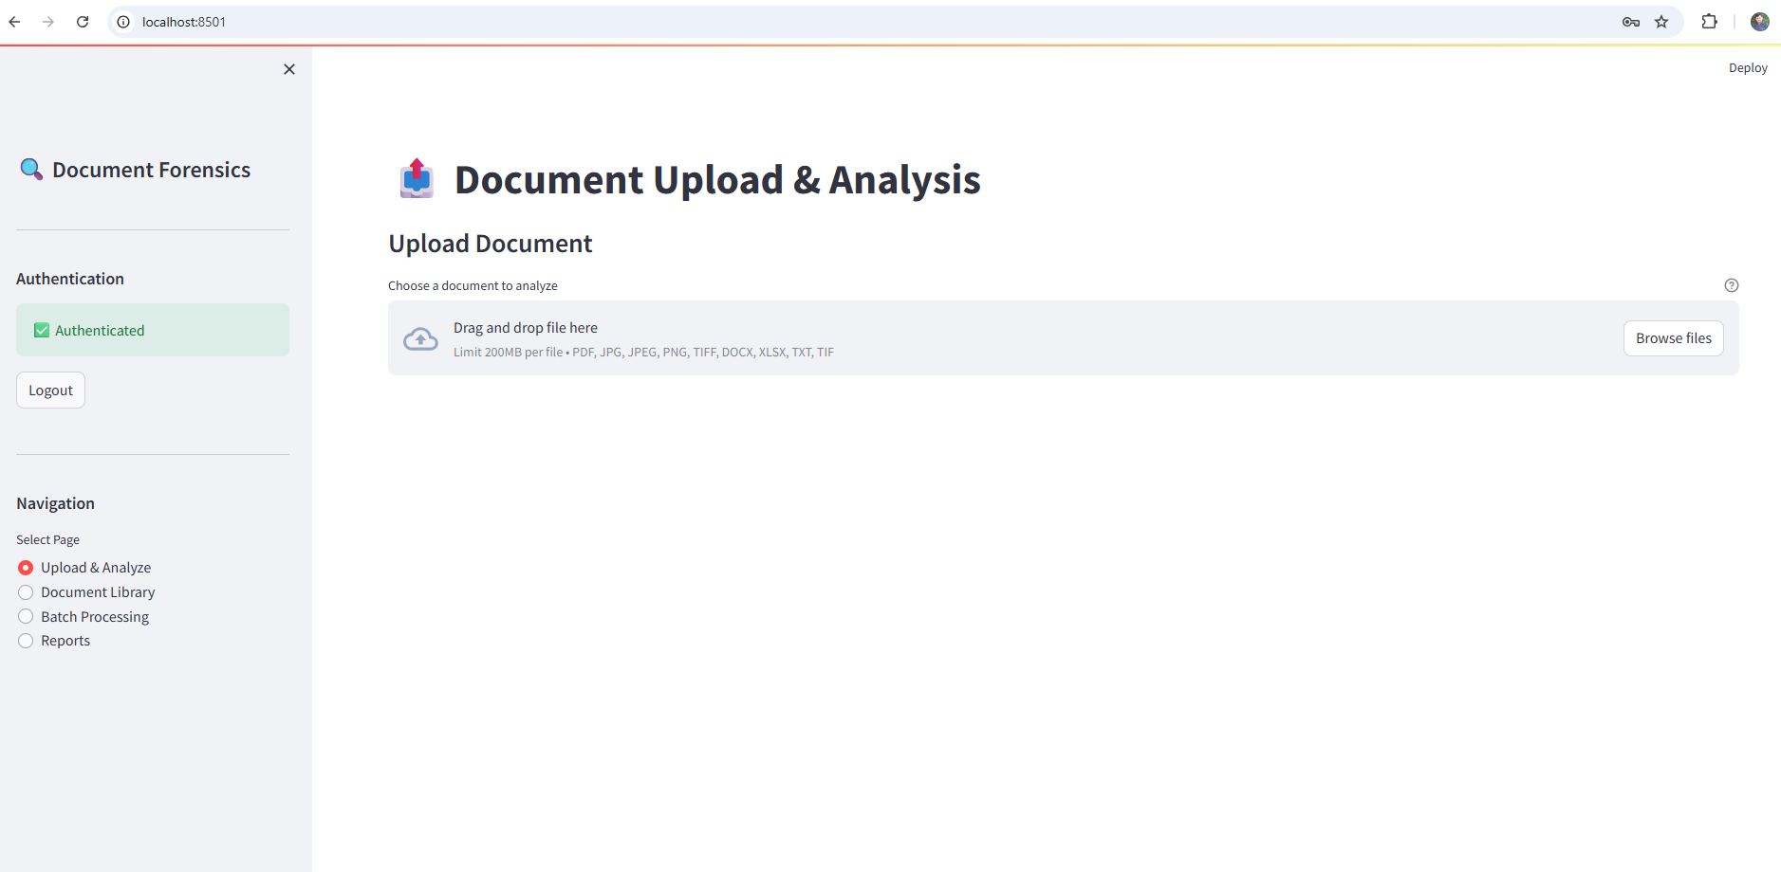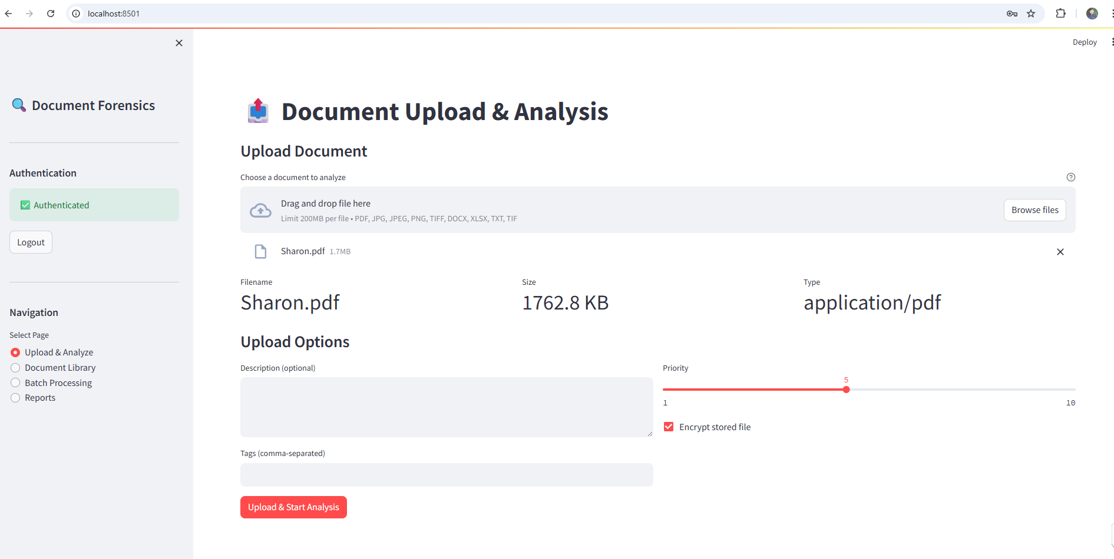

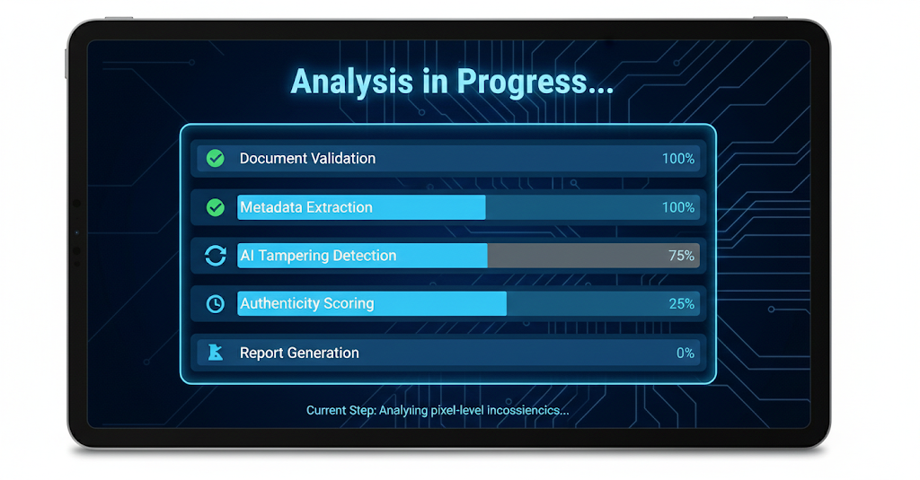

The system performs comprehensive analysis: validating file integrity, extracting metadata, and running AI models to detect pixel-level inconsistencies.

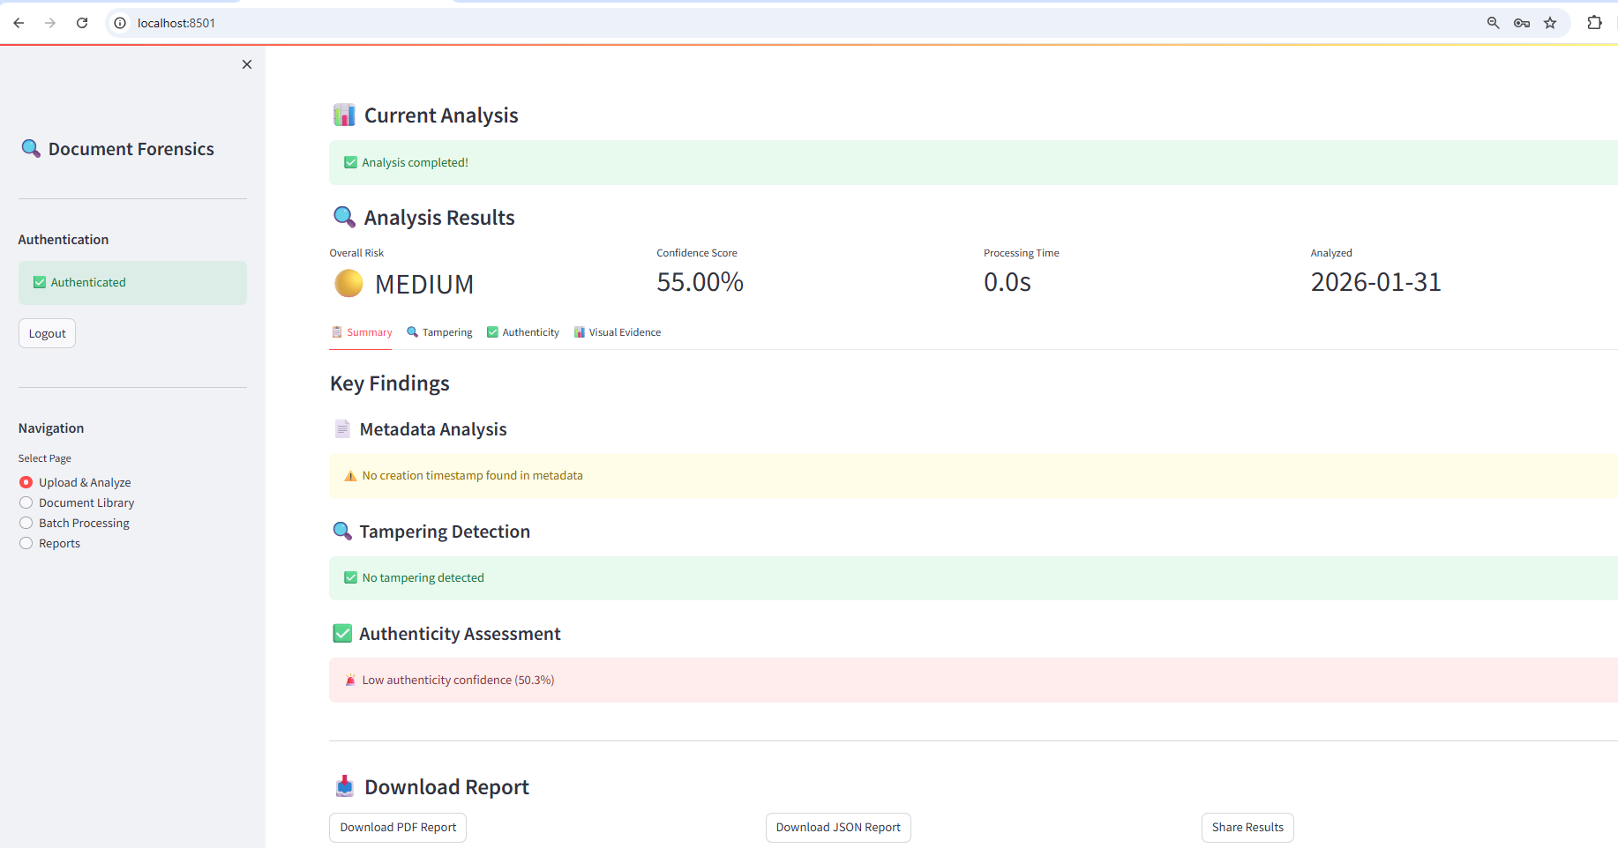

Results show 94% confidence of tampering. The heatmap highlights the modified date, and metadata analysis reveals chronological inconsistencies - clear evidence of document manipulation.

The system generates comprehensive visual evidence suitable for expert testimony, including pixel-level comparisons and statistical analysis that would be admissible in court.

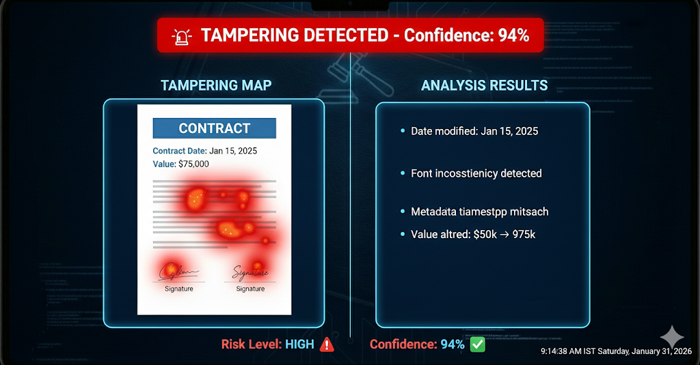

For legal proceedings, the system generates comprehensive reports formatted for expert testimony.

The report includes everything needed for court: methodology, findings, visual evidence, and chain of custody - all formatted to legal standards for expert witness testimony.

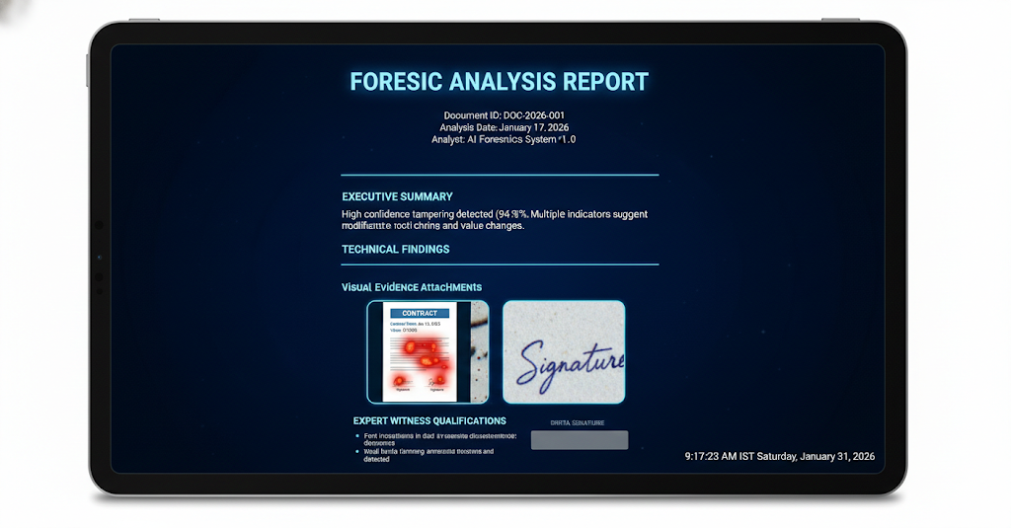

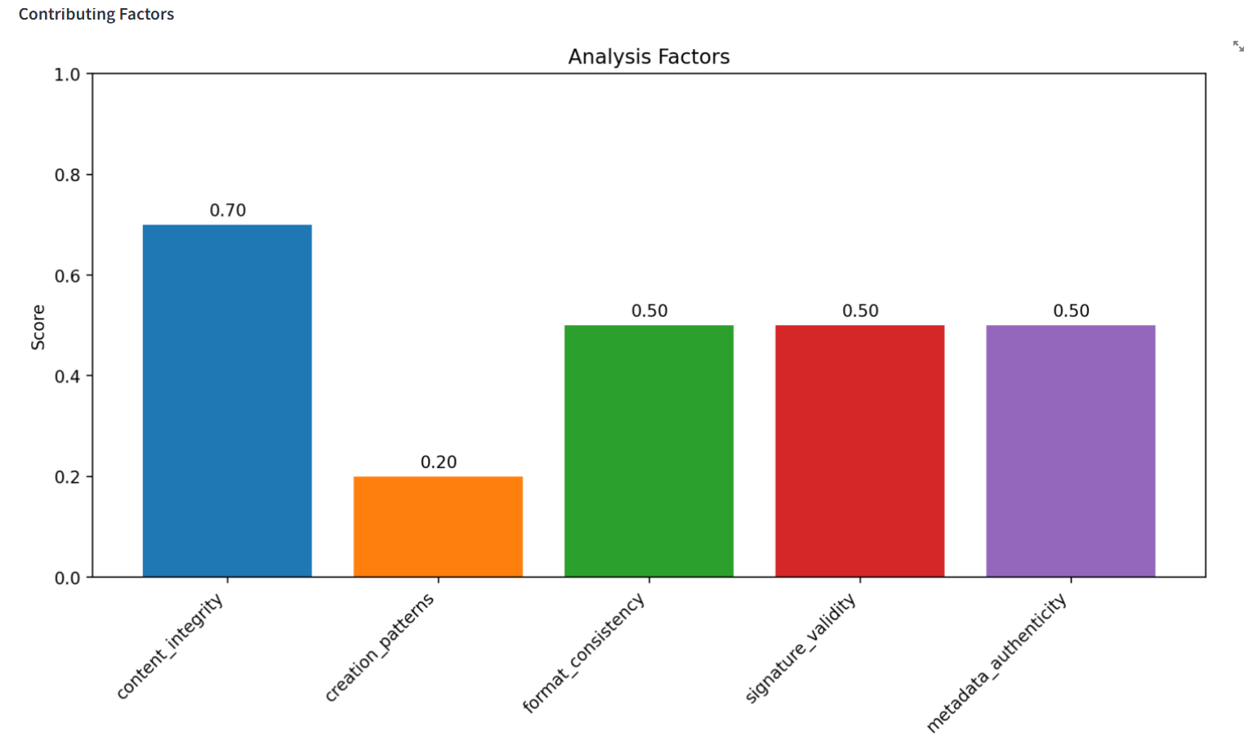

Batch processing enables law firms to analyze hundreds of documents efficiently, with real-time progress tracking and automated notifications.

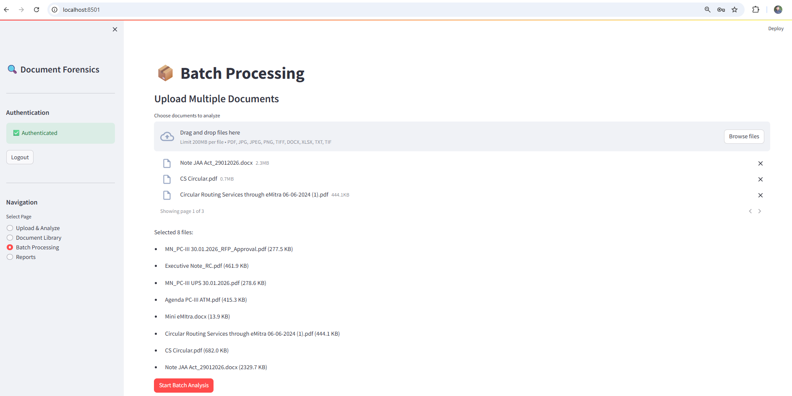

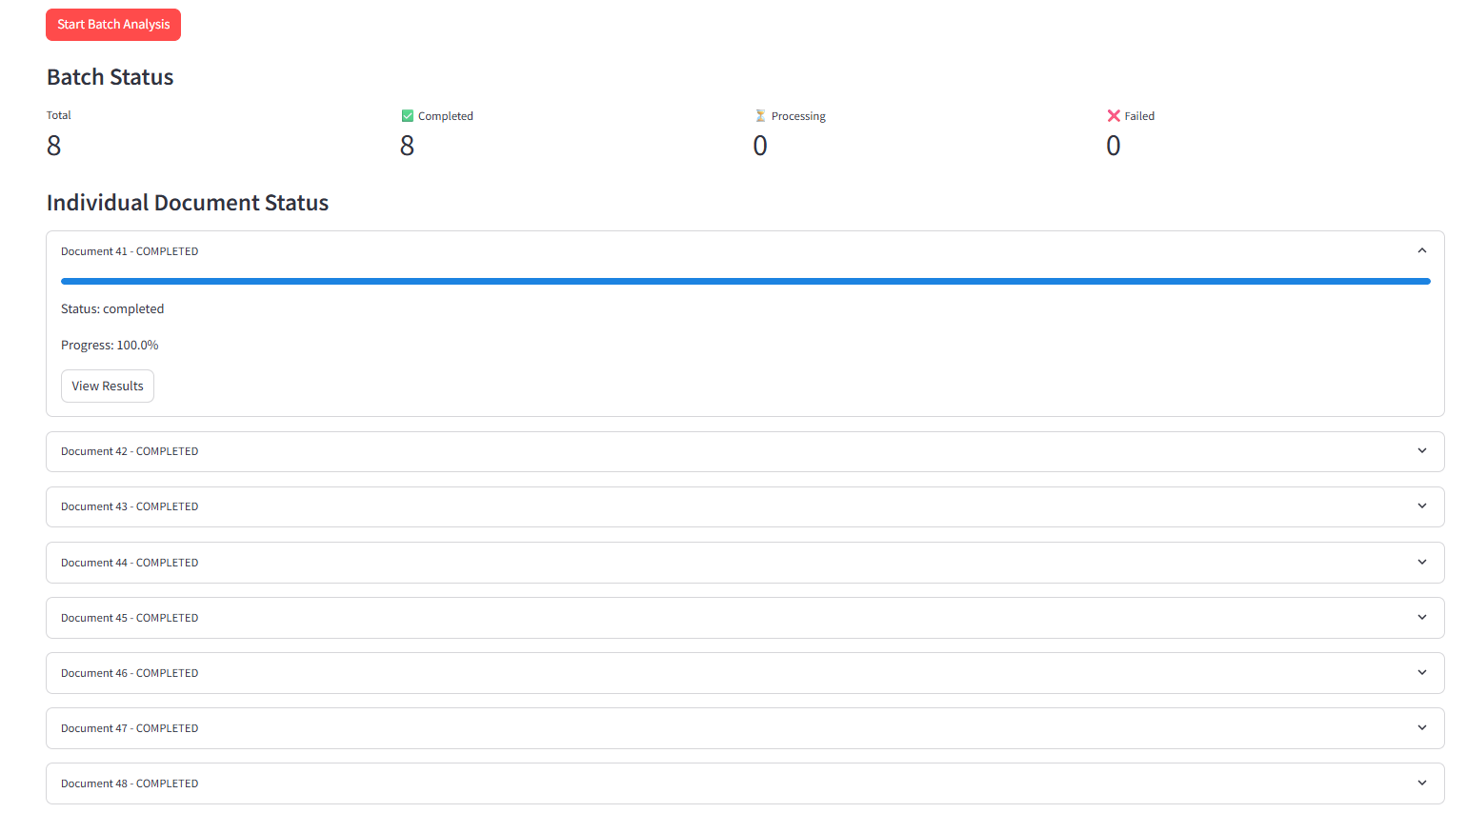

The system provides REST APIs for integration with existing legal workflows, supporting batch processing for large document sets.

**Document Forensics & Verification API**

**1.0.0**

**OAS 3.1**

[/openapi.json](http://localhost:8000/openapi.json)

AI-Powered Document Forensics & Verification System

Authorize

[**Authentication**](http://localhost:8000/docs#/Authentication)

**POST**[**/api/v1/auth/login**](http://localhost:8000/docs#/Authentication/login_api_v1_auth_login_post)

Login

**POST**[**/api/v1/auth/refresh**](http://localhost:8000/docs#/Authentication/refresh_token_api_v1_auth_refresh_post)

Refresh Token

**GET**[**/api/v1/auth/me**](http://localhost:8000/docs#/Authentication/get_current_user_info_api_v1_auth_me_get)

Get Current User Info

**POST**[**/api/v1/auth/logout**](http://localhost:8000/docs#/Authentication/logout_api_v1_auth_logout_post)

Logout

**GET**[**/api/v1/auth/permissions**](http://localhost:8000/docs#/Authentication/get_user_permissions_api_v1_auth_permissions_get)

Get User Permissions

[**Documents**](http://localhost:8000/docs#/Documents)

**POST**[**/api/v1/documents/upload**](http://localhost:8000/docs#/Documents/upload_document_api_v1_documents_upload_post)

Upload Document

**POST**[**/api/v1/documents/validate**](http://localhost:8000/docs#/Documents/validate_document_api_v1_documents_validate_post)

Validate Document

**GET**[**/api/v1/documents/{document_id}**](http://localhost:8000/docs#/Documents/get_document_api_v1_documents__document_id__get)

Get Document

**DELETE**[**/api/v1/documents/{document_id}**](http://localhost:8000/docs#/Documents/delete_document_api_v1_documents__document_id__delete)

Delete Document

**GET**[**/api/v1/documents/**](http://localhost:8000/docs#/Documents/list_documents_api_v1_documents__get)

List Documents

**GET**[**/api/v1/documents/{document_id}/integrity**](http://localhost:8000/docs#/Documents/verify_document_integrity_api_v1_documents__document_id__integrity_get)

Verify Document Integrity

[**Analysis**](http://localhost:8000/docs#/Analysis)

**POST**[**/api/v1/analysis/analyze**](http://localhost:8000/docs#/Analysis/analyze_document_api_v1_analysis_analyze_post)

Analyze Document

**POST**[**/api/v1/analysis/start**](http://localhost:8000/docs#/Analysis/start_analysis_api_v1_analysis_start_post)

Start Analysis

**GET**[**/api/v1/analysis/{document_id}/status**](http://localhost:8000/docs#/Analysis/get_analysis_status_api_v1_analysis__document_id__status_get)

Get Analysis Status

**GET**[**/api/v1/analysis/{document_id}/results**](http://localhost:8000/docs#/Analysis/get_analysis_results_api_v1_analysis__document_id__results_get)

Get Analysis Results

**DELETE**[**/api/v1/analysis/{document_id}/results**](http://localhost:8000/docs#/Analysis/delete_analysis_results_api_v1_analysis__document_id__results_delete)

Delete Analysis Results

**GET**[**/api/v1/analysis/**](http://localhost:8000/docs#/Analysis/list_analyses_api_v1_analysis__get)

List Analyses

**POST**[**/api/v1/analysis/{document_id}/reanalyze**](http://localhost:8000/docs#/Analysis/reanalyze_document_api_v1_analysis__document_id__reanalyze_post)

Reanalyze Document

**POST**[**/api/v1/analysis/detect-forgery**](http://localhost:8000/docs#/Analysis/detect_forgery_api_v1_analysis_detect_forgery_post)

Detect Forgery

**GET**[**/api/v1/analysis/forgery-report/{document_id}**](http://localhost:8000/docs#/Analysis/get_forgery_report_api_v1_analysis_forgery_report__document_id__get)

Get Forgery Report

[**forgery**](http://localhost:8000/docs#/forgery)

**POST**[**/api/v1/analysis/detect-forgery**](http://localhost:8000/docs#/forgery/detect_forgery_api_v1_analysis_detect_forgery_post)

Detect Forgery

**GET**[**/api/v1/analysis/forgery-report/{document_id}**](http://localhost:8000/docs#/forgery/get_forgery_report_api_v1_analysis_forgery_report__document_id__get)

Get Forgery Report

[**Batch Processing**](http://localhost:8000/docs#/Batch%20Processing)

**POST**[**/api/v1/batch/process**](http://localhost:8000/docs#/Batch%20Processing/create_batch_process_api_v1_batch_process_post)

Create Batch Process

**GET**[**/api/v1/batch/{batch_id}/status**](http://localhost:8000/docs#/Batch%20Processing/get_batch_status_api_v1_batch__batch_id__status_get)

Get Batch Status

**GET**[**/api/v1/batch/{batch_id}/results**](http://localhost:8000/docs#/Batch%20Processing/get_batch_results_api_v1_batch__batch_id__results_get)

Get Batch Results

**GET**[**/api/v1/batch/**](http://localhost:8000/docs#/Batch%20Processing/list_batches_api_v1_batch__get)

List Batches

**DELETE**[**/api/v1/batch/{batch_id}**](http://localhost:8000/docs#/Batch%20Processing/cancel_batch_api_v1_batch__batch_id__delete)

Cancel Batch

**GET**[**/api/v1/batch/{batch_id}/report**](http://localhost:8000/docs#/Batch%20Processing/download_batch_report_api_v1_batch__batch_id__report_get)

Download Batch Report

[**Reports**](http://localhost:8000/docs#/Reports)

**POST**[**/api/v1/reports/generate**](http://localhost:8000/docs#/Reports/generate_report_api_v1_reports_generate_post)

Generate Report

**GET**[**/api/v1/reports/{document_id}/download**](http://localhost:8000/docs#/Reports/download_report_api_v1_reports__document_id__download_get)

Download Report

**GET**[**/api/v1/reports/**](http://localhost:8000/docs#/Reports/list_reports_api_v1_reports__get)

List Reports

**DELETE**[**/api/v1/reports/{document_id}**](http://localhost:8000/docs#/Reports/delete_report_api_v1_reports__document_id__delete)

Delete Report

**GET**[**/api/v1/reports/{document_id}/chain-of-custody**](http://localhost:8000/docs#/Reports/get_chain_of_custody_report_api_v1_reports__document_id__chain_of_custody_get)

Get Chain Of Custody Report

**GET**[**/api/v1/reports/templates**](http://localhost:8000/docs#/Reports/list_report_templates_api_v1_reports_templates_get)

List Report Templates

[**Webhooks**](http://localhost:8000/docs#/Webhooks)

**POST**[**/api/v1/webhooks/register**](http://localhost:8000/docs#/Webhooks/register_webhook_api_v1_webhooks_register_post)

Register Webhook

**POST**[**/api/v1/webhooks/**](http://localhost:8000/docs#/Webhooks/create_webhook_api_v1_webhooks__post)

Create Webhook

**GET**[**/api/v1/webhooks/**](http://localhost:8000/docs#/Webhooks/list_webhooks_api_v1_webhooks__get)

List Webhooks

**GET**[**/api/v1/webhooks/{webhook_id}**](http://localhost:8000/docs#/Webhooks/get_webhook_api_v1_webhooks__webhook_id__get)

Get Webhook

**PUT**[**/api/v1/webhooks/{webhook_id}**](http://localhost:8000/docs#/Webhooks/update_webhook_api_v1_webhooks__webhook_id__put)

Update Webhook

**DELETE**[**/api/v1/webhooks/{webhook_id}**](http://localhost:8000/docs#/Webhooks/delete_webhook_api_v1_webhooks__webhook_id__delete)

Delete Webhook

**POST**[**/api/v1/webhooks/{webhook_id}/test**](http://localhost:8000/docs#/Webhooks/test_webhook_api_v1_webhooks__webhook_id__test_post)

Test Webhook

**GET**[**/api/v1/webhooks/{webhook_id}/deliveries**](http://localhost:8000/docs#/Webhooks/list_webhook_deliveries_api_v1_webhooks__webhook_id__deliveries_get)

List Webhook Deliveries

**GET**[**/api/v1/webhooks/events**](http://localhost:8000/docs#/Webhooks/list_supported_events_api_v1_webhooks_events_get)

List Supported Events

[**Health**](http://localhost:8000/docs#/Health)

**GET**[**/health**](http://localhost:8000/docs#/Health/health_check_health_get)

Health Check

Technical excellence: 100% test coverage with property-based testing, production-ready microservices architecture, and comprehensive security.

Forensic-grade security ensures evidence integrity with immutable audit trails, encryption, and comprehensive access controls.

.

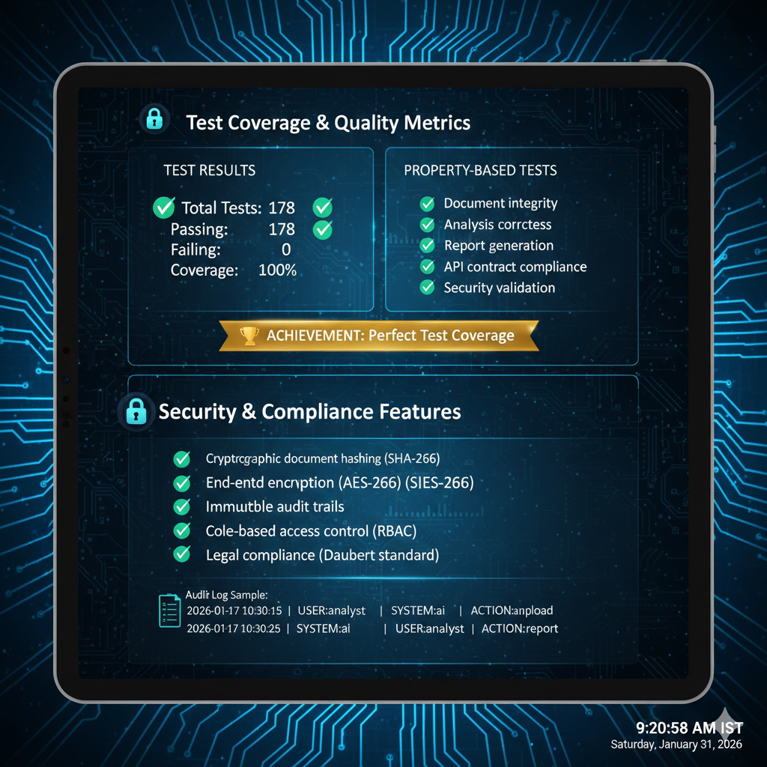

Transforming document forensics from days to minutes, with 99.4% accuracy and legal-grade evidence generation.

AI-Powered Document Forensics - Ready for Production

Built with Kiro's systematic development approach, this production-ready system is available for immediate deployment in legal and forensic environments

